October 21st, 2019

Robert A. Emmons, Editor-in-Chief

*Journal of Positive Psychology*

Re: “Longitudinal Associations between Character Strengths and Civic Action: A Daily Diary Study”

Dear Dr. Emmons,

My co-authors and I would like to submit the attached manuscript for possible publication in *Journal of Positive Psychology* as an empirical article. The manuscript is consistent with the goals of *Journal of Positive Psychology*, as it uses daily diary data collected from *N* = 235 participants to examine longitudinal, bi-directional associations between character strengths and civic engagement during a time of heightened national political engagement. Findings from this study advance both theory and policy by highlighting that certain character strengths—including sense of purpose, future-mindedness, and gratitude—both precede and follow civic action. We have complied with APA standards for the ethical treatment of research participants in conducting this research, and my co-authors and I are in agreement with the content of this manuscript. The manuscript is not under consideration elsewhere.

We look forward to hearing from you.

Best regards,

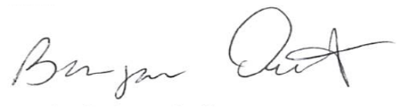

Benjamin Oosterhoff

Address correspondence to:

Benjamin Oosterhoff

Assistant Professor

Department of Psychology

Montana State University

E-mail: Benjamin.oosterhoff@montana.edu